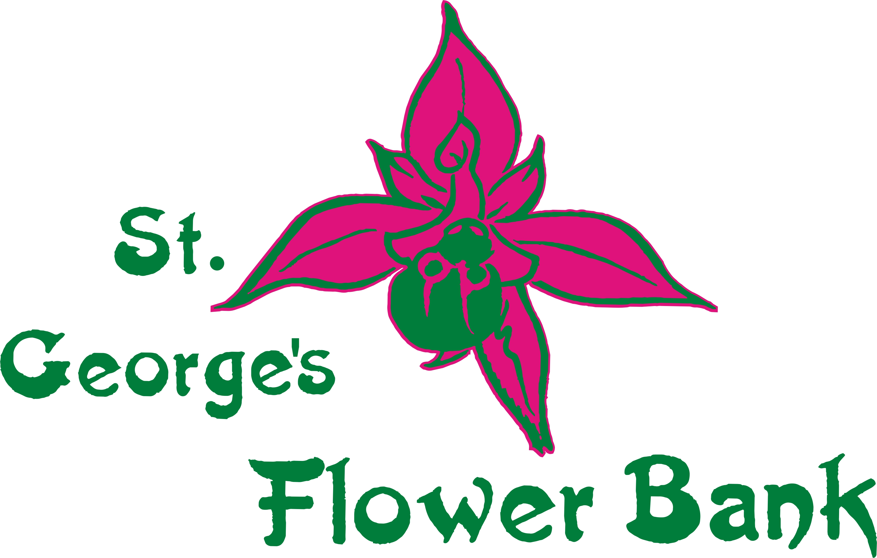

newsletter October 2021

The good news gets better!

All the paperwork is done – we’re back in business!
Look out for details of workparties SOON

Helping others*
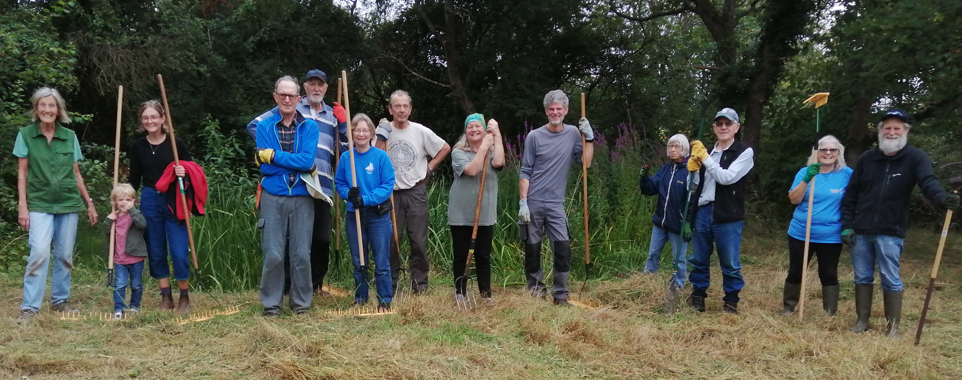

Even though we didn’t work on the Flower Bank
we’ve not been idle this summer.

*The Paddock: Brookside: Macrae Road: Hardwick Road; Penny Brohn

Extraordinary generosity
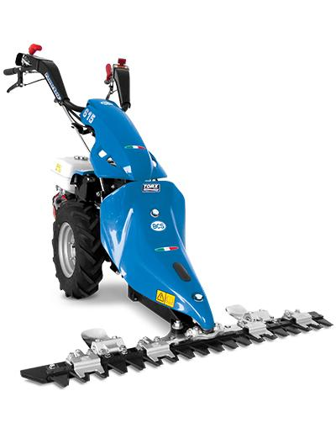
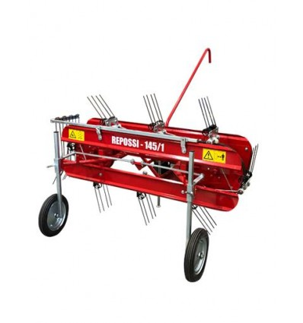

Two separate donations out of the blue mean we will soon have a new machinery
a replacement scythe-bar mower and a mechanical hay-rake.
More details will be shared when we actually get the kit.

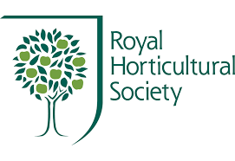
South West in Bloom awards

‘Outstanding’ for 4th time!

The Monk Trophy for ‘Best Use of Native Plants’
in the whole of the South West

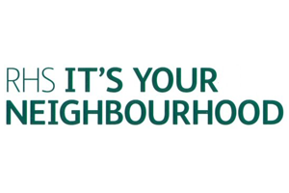

Do YOU want to be part of this team?
All you need is a bit of time and lots of enthusiasm!!
Contact
stgeorgesflowerbank@gmail.com
0788 4400221

